**Thermodynamic Database Format**

A thermodynamic database, which stored the Gibbs energy function of every phase of interest in the system, is an essential part of thermodynamic calculation by the CALPHAD approach. Software must load in a thermodynamic database before performing any calculations. Due to the complexity of thermodynamic models, the format of a thermodynamic database must be well defined. The most widely used format is the so called TDB format. We will describe this format in some details, and mention other formats briefly at the end of this section. Figure 1 shows a typical TDB file based on the Al-Ni binary system. It is for the purpose of illustration and is not a full database.

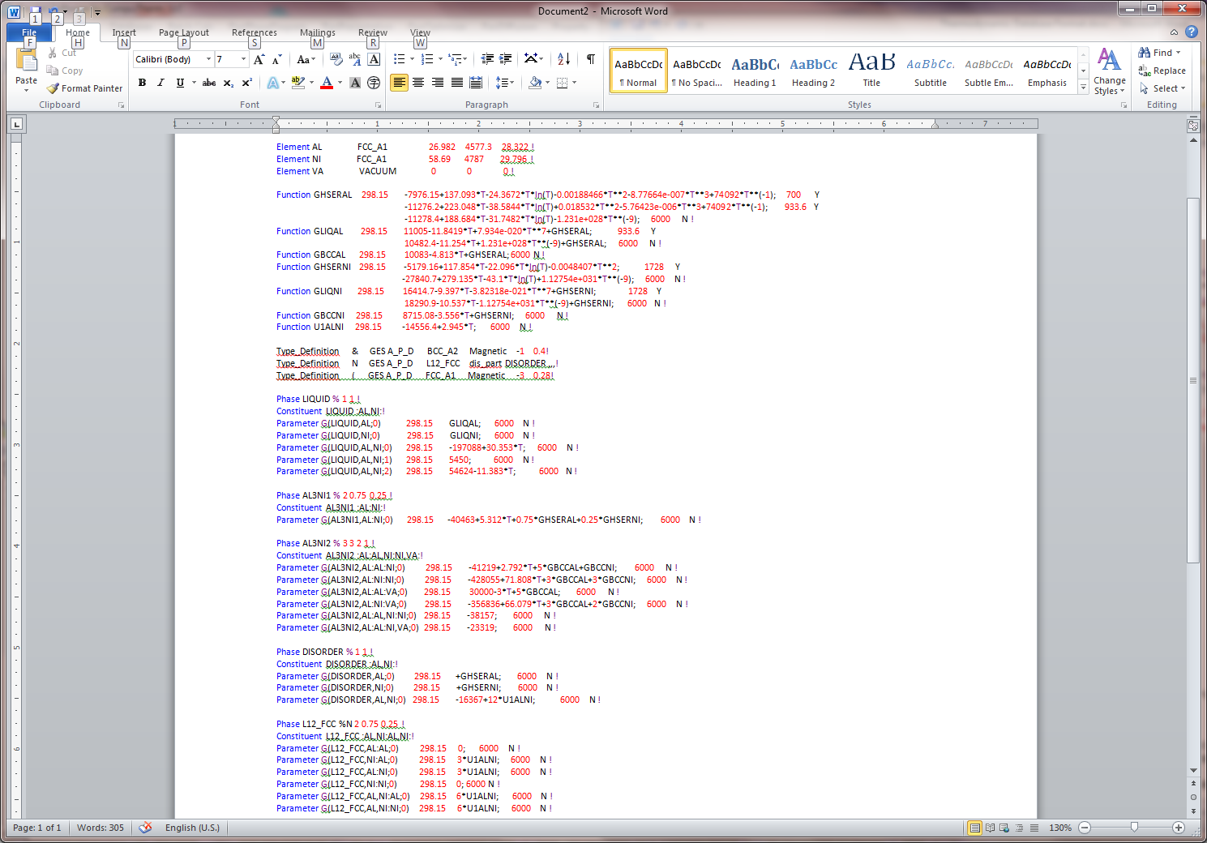

Figure 1: Partial database of the Al-Ni binary system showing the typical TDB format

The TDB file usually consists of four sections: Elements, Function, Type_Definition, and Phase. The key words are highlighted with blue color as shown in Figure 1. At the beginning, the Elements section defines every component that included in the database. Following each element, the stable structure at room temperature, the atomic weight, the enthalpy and the entropy of this element at 298K in its most stable state at room temperature are given. In the Function section, the Gibbs energies of each pure element with different crystal structures are usually listed as segmental function of temperature. The lower and upper temperature limits are given at the beginning and end of each segmental function. The symbol “Y” following the upper limit means there is another temperature range above this upper temperature limit. The symbol “N !” means it is the end of the function. These Gibbs energies are referred to the standard element reference (SER) state (298.15K and pressure of 1 bar). At this state, the enthalpy of the element in its most stable structure is set to be zero by convention. In this section, database developer can also define some functions that can be used directly in the Phase section. The Type_Definition section defines other features related to a particular phase. In Figure 1, “&” is used to define the magnetic parameters of BCC_A2 phase, and “N” defines that L12_FCC has a disordered contribution to its Gibbs energy. The major body of a TDB file is the Phase section. In this section, thermodynamic model is defined and model parameters are listed for each phase involved in the system. Some details are given below for the phases listed in Figure 1.

Description of each phase starts with the key word Phase following the phase name. The % symbol separates the phase name and the phase description, i.e., sublattice information. If the phase has other features, such as magnetic contribution or disordered contribution, the symbol defined in the Type_Definition should follow % symbol without any space. If this phase has no other feature, leave a space after %. The LIQUID phase in Figure 1 is described as a substitutional solution phase. The first “1” after % symbol means that it has one sublattice and the second “1” means the fraction of this sublattice is 1. The next line defines the constituents of each sublattice starting with the key word Constituent following the phase name and then the constituents in each sublattice. The following lines are the model parameters. The first two lines represent the reference state, and the next three lines are the excess Gibbs energy terms. More information can be found in Section ###: Thermodynamic Models. In the example of Figure 1, the Gibbs energy of LIQUID (J/mol) is:

$$G_{LIQUID}=x_{Al}*GLIQAL+x_{Ni}*GLIQNI+RT\left(x_{Al}lnx_{Al}+x_{Ni}lnx_{Ni}\right)+x_{Al}x_{Ni}[\left(-197088+30.353*T\right)+5450\left(x_{Al}-x_{Ni}\right)+\left(54624-11.383*T\right){\left(x_{Al}-x_{Ni}\right)}^{2}]$$

Notice that the functions: *GLIQAL* and *GLIQNI* defined in the Function section can be directly used here. The next phase in Figure 1 is AL3NI1. In the first line after phase name and symbol %, this phase is defined to have two sublattices. The fraction of the first sublattice is 0.75 and that of the second it 0.25. The second line defines that AL occupies the first sublattice and NI the second sublattice. The AL3NI1 is therefore a line compound. The Parameter line gives the Gibbs energy of AL3NI1 (J/mole atoms) as:

$$G_{AL3NI1}=0.75*GHSERAL+0.25*GHSERNI-40463+5.312*T$$

The third phase in Figure 1 is AL3NI2 which contains three sublaticces. The sizes of these three sublattices are defined as 3, 2, and 1, respectively. It should be noticed that this definition defines a phase with six moles of atoms. The Parameters listed below are also for the Gibbs energy of six moles of atoms of this phase. In the Constituent line, it defines that AL occupies the first sublattice, the AL and NI occupy the second sublattice, and the NI and VA occupy the third sublattice. This is an ordered intermetallic phase, and its Gibbs energy is described by the Compound-Energy Formalism. In the phase definition, a comma is used to separate species in the same sublattice, whilst a colon is used to separate species belonging to different sublattices. The following Parameter lines give the Gibbs energy of six mole atoms of AL3NI2 as:

$G_{AL3NI2}=y_{Al}^{I}y_{Al}^{II}y_{Ni}^{III}\left(-41219+2.792*T+5*GBCCAL+GBCCNI\right)+y_{Al}^{I}y_{Ni}^{II}y_{Ni}^{III}\left(-428055+71.808*T+3*GBCCAL+3*GBCCNI\right)+y_{Al}^{I}y_{Al}^{II}y_{Va}^{III}\left(30000-3*T+5*GBCCAL\right) +y_{Al}^{I}y_{Ni}^{II}y_{Va}^{III}\left(-356836+66.079*T+3*GBCCAL+2*GBCCNI\right) +y_{Al}^{I}{y_{Al}^{II}y}_{Ni}^{II}y_{Ni}^{III}\left(-38157\right)+y_{Al}^{I}{y_{Al}^{II}y}_{Ni}^{III}y_{Va}^{III}\left(-38157\right)+RT[3*y_{Al}^{1}lny_{Al}^{I}+2*\left(y_{Al}^{II}lny_{Al}^{II}+y_{Ni}^{II}lny_{Ni}^{II}\right)+\left(y_{Ni}^{III}lny_{Ni}^{III}+y_{Va}^{III}lny_{Va}^{III}\right)$]

It should be pointed out that $y_{Al}^{I}=1$ in the above equation since AL is the only species that occupies the first sublattice.

The next Phase, DISORDER, is actually part of the following Phase L12_FCC. It is seen, the phase name L12_FCC is followed by %N. In the Type_Definition, “N” is symbol to specify that L12_FCC has a disordered contribution from DISORDER. In this case the Gibbs energy of L12_FCC (J/mole atoms) is written as:

$$G_{L12_FCC}=\left[G_{L12_Ord}\left(y_{i}^{s}\right)-G_{L12_Ord}\left(y_{i}^{s}=x_{i}\right)\right]+G_{DISORDER}$$

For the L12_FCC phase in Figure 1, we have:

$$G_{L12_Ord}=y_{Ni}^{I}y_{Al}^{II}\left(3*U1ALNI\right)+y_{Al}^{I}y_{Ni}^{II}\left(3*U1ALNI\right)+y_{Al}^{I}y_{Ni}^{I}y_{Al}^{II}\left(6*U1ALNI\right)+y_{Al}^{I}y_{Ni}^{I}y_{Ni}^{II}\left(6*U1ALNI\right)+RT[0.75*\left(y_{Al}^{I}lny_{Al}^{I}+y_{Ni}^{I}lny_{Ni}^{I}\right)+0.25*\left(y_{Al}^{II}lny_{Al}^{II}+y_{Ni}^{II}lny_{Ni}^{II}\right)]$$

$$G_{DISORDER}=x_{Al}GHSERAL+x_{Ni}GHSERNI+x_{Al}x_{Ni}\left(-16367+12U1ALNI\right)+RT(x_{Al}lnx_{Al}+x_{Ni}lnx_{Ni})$$

The general format of TDB can be read by several software packages, such as Thermo_Calc and PANDAT. However, minor differences do exist for the TDB files used by different software package. For example, some new key words and Property names are defined in the TDB file that is readable by PANDAT. Figure 2 gives such an example. In this example, key word Optimization is used to define a variable that is to be optimized. Following this key word is the name, the low limit, high limit, and the initial value of the variable. New property parameters, such as Molar Volume (VM), Activation Energy (ACTIVATIONENERGY), Surface Tension (SURFACETENSION) can be defined in the TDB file when using PANDAT software.

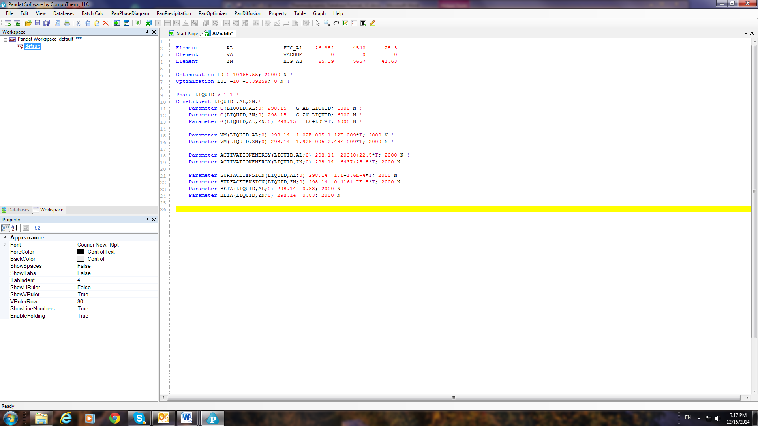

Figure 2: An example TDB showing new key words defined by PANDAT software

Other database formats were also developed to be used by variety of software packages. One of the legacy software for phase diagram calculation, the Lukas program used DB format. Details on this database format can be found in the book “Computational Thermodynamics: The Calphad method” [ref1]. FactSage has developed Compound databases and Solution databases on oxides, salts and so on systems. The format of FactSage databases can be found in the literature [ref2, ref3].

[ref1]: H. L. Lukas, S. G. Fries, B. Sundman, Computational Thermodynamics: The Calphad method, Cambridge University Press, 1st edition, 2007

[ref2]: C. W. Bale et. al., Calphad, 26(2) (2002), p189-228.

[ref3]: C. W. Bale et. al., Calphad, 33 (2009), p295-311.